**Welcome to the Catholic Parishes of:**

  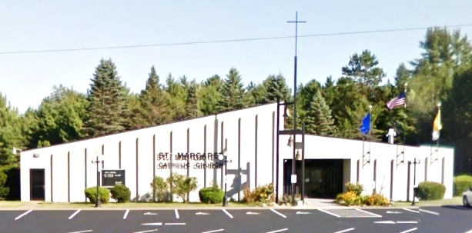

***St. Anthony of Padua Sacred Heart of Jesus St. Margaret of Scotland***

*1432 River St. W778 County Road N N18844 Hwy 141*

*Niagara, WI 54151 Aurora, WI 54151 P.O. Box 235 Pembine, WI 54156*

*(715) 251-3879 St. Anthony office hours 9am-12noon on Thursday (715)324-5849*

*office.stanthonyniagara@gmail.com* **Website:** [**www.stanthonyniagara.org**](http://www.stanthonyniagara.org) [*stmargaretpembine@gmail.com*](mailto:stmargaretpembine@gmail.com)



***Year B: 12th Sunday Ordinary***

***June 23rd, 2024***

**Our Lady of Fatima First Saturday Devotions**:

8am Adoration, Rosary, Confessions

9:00am Mass, enrollment of scapular afterward

*Next First Saturday Event: July 6th*

**“The Lord addressed Job out of the storm”**

**WEEKDAY MASSES**

**St. Anthony**

Tuesday at 5:30pm

Wednesday at 8:00 am

Thursday at 5:30pm

**St. Margaret**

Friday at 9:00am

**CONFESSIONS**

½ hour before Mass

(Except at Sacred Heart and Wed AM at St. A)

**ADORATION:**

1 hour before weekday Masses

**WEEKEND MASSES**

**St. Margaret**

Saturday at 4:00pm

**St. Anthony**

Sunday at 9:00am

**Sacred Heart**

Sunday at 11:00am

The Month of June is dedicated to the Sacred Heart of Jesus

Remember, O most sweet Jesus, that no one who has had recourse to Thy Sacred Heart, implored its help, or sought its mercy was ever abandoned. Encouraged with confidence, O tenderest of hearts, we present ourselves before Thee, crushed beneath the weight of our sins. In our misery, O Sacred Heart of Jesus, despise not our simple prayers, but mercifully grant our requests.

***Calendar of Events & Mass Intentions:***

**Saturday, June 22nd**

3:30pm Confessions at St. Margaret

4:00pm St. Margaret Mass, Int: Donna Weber

**Sunday, June 23rd**

8:30am Confessions at St. Anthony

9am St. A Mass, Int: For the people

11am Mass Sacred Heart, Int: Elizabeth Rooney

Confessions available after Mass upon request

12pm Sacred Heart Parish Picnic (potluck)

**Monday, June 24th**

**Tuesday, June 25th**

4:30pm St. Anthony Adoration, 5pm Confession

5:30pm St. Anthony Mass, Int: Mary Carini

**Wednesday, June 26th**

8:00am St. Anthony Mass, Int: Michael Carini

10:00-11:30am Fr. Felix Office Hours

**Thursday, June 27th**

9:30am Mass at Maryhill Manor 60th Anniversary celebration with Fr. Girotti

4:30pm St. Anthony Adoration, 5pm Confession

5:30pm St. Anthony Mass, Int: Bob Beauchamp

**Friday, June 28th**

8:00am St. Margaret Adoration, 8:30am Confession

9:00am St. Margaret Mass, Int:

**Saturday, June 29th**

3:30pm Confessions at St. Margaret

4:00pm St. Margaret Mass, Int: For the people

**Sunday, June 30th**

8:30am Confessions at St. Anthony

9am St. A Mass, Int: Sr. Roselyn Nichols

11am Mass Sacred Heart, Int: James Rooney

Confessions available after Mass upon request

**Please pray for those in need of prayer.**

Jim Butzler,  Donna Weber, Laurie Morin, Roberta Vondall, Jimmy Farrington, Donna Moreau, Mike Michaud, Kim Geib, Kaydence M. Gilbert, June Anderson, Nick DalSanto, Mary Stewart, Blake Fleury, Mark Endres, John Geib, Peter N., Lucinda Simone, Diane Rock, David Rock Sr., Geri Scheidt , Jeremy and Paula Conery, Nathan Glime & family, Elias Zarate, Riley Lestrud, Elijah, Duke family, Neil Anderson, Christopher Schoon, Jenna Erno, Dan Wetzel, Eric Frantz, Ellie Mae, Keri Rugg, Steve Keeley, Debbie Ziebert, Kelly Jean Rose-Lehto, Trish Gardiner, Robin Rugg, June Uren, Marcie & Jim Crandall, Dick Doucette, Bonnie Nowland, Tom Balthazor, Jana Wood, Kathy Martin, Connor Wallace, Bob Butler, Robert Walters, Jody Wall, Roger Karban, Dan Hughes, Eric Kellings, Barb Schultz, Carol Scheidt, Al Swanson

**Nursing home:** Terry and Cheri Sweig

**Please keep our soldiers in your prayers:** Sarah Mills, David Phillips, Emily Phillips, Benjamin Oratch, Ben Garvaglia

***Please call Rose Bousley for intention 715-251-3249***

**Personnel**

Pastor (Temporary Administrator): Fr. Felix Abano, Jr.

Accountant: Cain Accounting

Secretary& RE Coord: Dawn Johnson, 715-251-1773

RE Assistant: Donna Henrichs

St A Maintenance: Randy Pilon, 920-850-6998

St A cleaning person: Veronica Church

St Margaret Secretary: Pam Vross

St Margaret Maintenance: Charles Kuhns

St Margaret Trustees: Andy VandenBush & Ed Nowland

Sacred Heart Trustees: Jim Carncross & Pat Schaut

St Anthony Trustees: Tony Noska & Judy Parent

**GROUP MINISTRIES**

* Karen’s Pantry Contact Teresa: 906.239.4662
* Prayer Shawl Ministry –1st Wednesday at 10am 2nd floor in SVdP room. Call Cindy Pilon 920.851.7316
* SACCW –President Laura Brinkman 906.869.8868 next mtg:
* K of Columbus –2nd Tues of month @ 5:30pm in hall
* Finance Council – next mtg: Tuesday, July 23, 6:30pm
* Pastoral Council - next mtg: at 6:15pm
* Worship Committee – next mtg:

St. Anthony parish needs volunteers to serve on the finance council. Please let us know if you can help.

**Saint Anthony Giving 6/2**

(Weekly exp =$2,750) Collection: $739

**Saint Margaret Giving 6/8**

Collection: $821.25

**Sacred Heart Giving 6/2 and 6/9**

Collection: $285 and $525

**Weekly Bible Reading for Mass:**

We are praying the Sunday Readings using *Lectio Divina* in the upstairs room off the RE office at 8am on December 10th, and 17th. Everyone is welcome!

**Sun the 23rd**: Psalter IV, Ordinary Time Week 12.

Job 8:1-11; Ps107:23-31; 2Cor5:14-17; Mk 4:35-41

**Mon the 24th:**  Solemnity Birth of John the Baptist.

Isa 49:1-6; Ps 139:1-15; Acts 13:22-26; Lk 1:57-80

**Tue the 25th:** 2 Kgs 19:9-36; Ps 48:1-11;Mt 7:6-14

**Wed the 26th**: 2 Kgs 22:8-13, 23:1-3; Ps 119:33-40; John 15:4-5; Mt 7:15-20

**Thu the 27th:** Cyril of Alexandra,

2 Kgs 24:8-17; Ps 79:1-9; John 14:23; Mt 7:21-29

**Fri the 28th:** Memorial of Irenaeus,

2 Kgs 25:1-12; Ps 137:1-6; Matt 8:17; Mt 8:1-4

**Sat the 29th:** Solemnity of Peter and Paul,

Acts 12:1-11; Ps 34:1-9; 2 Tim 4:6-18; Mt 16:13-19

**Candle Intentions for St. Anthony**

Infant Prague – Special Intention

**BISHOP’S APPEAL 2024:**

St. Anthony’s goal is $7,486 ($4,549 donated) and St. Margaret’s goal is $3,544 ($2,875 donated). Sacred Heart members, please feel free to use the cards provided to make a donation to one of your sister parishes.



**SACRED HEART** Parish Picnic (potluck) under the Pavilion is THIS WEEKEND Sunday, June 23rd after the 11am Mass.

**Project priority planning:** After hearing diocesan recommendations St A identified the top 5 priorities

1. Expand the parking by the garage. Includes a path to the office door
2. Remove and replace cement steps coming from the upper parking lot (install a hand rail on the other steps located closer to the hall.)
3. Remove and replace the old, clogged, clay storm drain on east side of the hall moving towards hwy.
4. Put in rain gutters along the east side of the hall to stop the water coming in
5. Blacktop the area around the bell tower and alley (and maybe by garage)

**St. Margaret’s-Pembine** is excited about, and preparing for, our 50th year Celebration (August 17th) in our current church. As we prepare, one of the events we will be having is a “basket raffle”. If anyone is interested in donating a basket or funds to prepare a basket, please contact the event leader, Mary Lou Neumann at 715-324-5738. Please plan to join us and keep us in your prayers as we prepare to celebrate.



**The leftover t-shirts and sweaters from fundraisers St. A held years ago are available once again! Choose the one or more that you want and leave a donation in the offertory.**

Musicians and Cantors needed at St. Anthony Parish. Please let us know if you are able to help out with our music during the weekend.

Unlike other lay liturgical ministers, EM’s, **Extraordinary Ministers of Holy Communion** (Communion Distributors) are to be commissioned for this ministry by the Bishop. This commissioning is proceeded by proper and sufficient spiritual, theological, and practical preparation to fulfill their role with knowledge and reverence. The next available formation opportunity is Saturday, August 3rd at St. Mary, Crivitz (10:00am-11:30am). If you have not yet been commissioned and are either serving as an EM or would like to, please let Fr. Felix know if you are able to attend or if you need another date for training. Bishop Ricken would like all parishes to receive the Eucharist under both species at special Masses. EM’s will be needed for these special events.

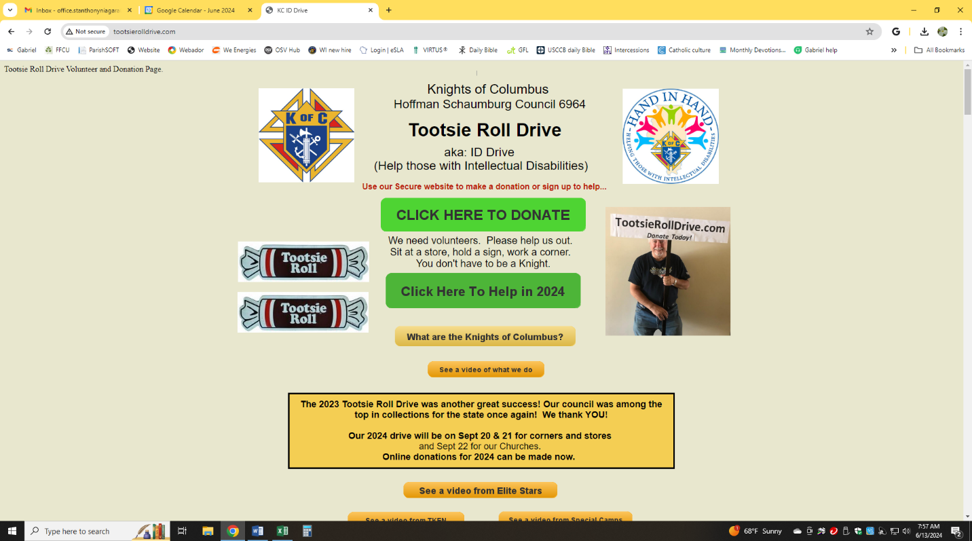**Tootsie Roll Drive** with the Knights of Columbus will take place THIS WEEKEND (June 22-23) at all three parishes. The proceeds are used to help those with intellectual disabilities.

**Starting July:**

* The Thursday evening 4:30pm adoration, 5pm confession, and 5:30pm Mass will be at Sacred Heart rather than at St. Anthony.
* The Tuesday Mass will no longer be available
* Mass intentions will increase to $20
* Stole stipends will be $75 for funerals and $100 for weddings.
* Fr. Felix will hold office hours on Wednesdays from 10-11:30am and Thursdays from 10:30-12noon in his office at St. Anthony. Look at the calendar on our website for updates from week to week.



Fr. Felix is hoping to get a lighted rosary to place outside. The cost is about $150.00. Would anyone be willing to donate for this? (This could be placed at any of the parishes)

|  |
| --- |
|  |

In Memory of the Deceased Members of the ***Kadulski Family***



***Deceased Members***

***of the Brinkman Family***



***Loving***

***Memory of:***

***Pat Recl a***



*In the Sacred Heart, every treasure of wisdom and knowledge is hidden. In that divine heart beats God’s infinite love for everyone and for each of us as individuals*. – St. John Paul II

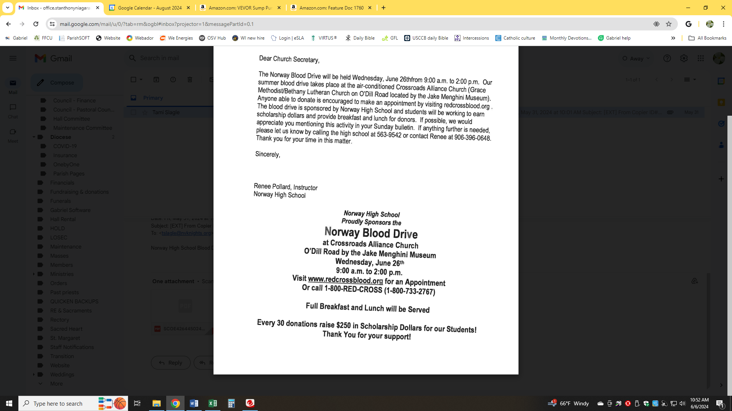

**AA Serenity Group**

**Wednesday 7:30pm at**

**St. Margaret Parish**

***Call Don 715-929-0011***



**In Loving**

**Memory of**

**Jim Merritt**



In Loving Memory of

***Jim & Mary***

***Parent***

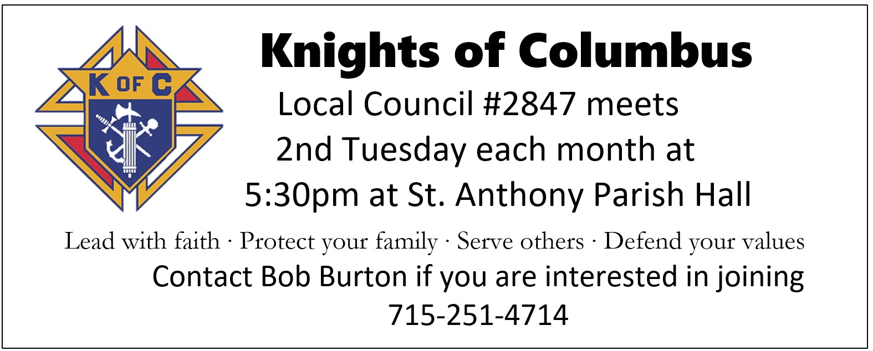

**Evergreen Assisted Living**

**Dignified Retirement Living**

*Complete Private Apartments - 3 Meals Daily - Transportation - Medicine Management - Emergency Call System – Memory Care Available*

**774-8943 * 1820 Mary’s Way, Kingsford**

***Stop in for a personal tour!***





**LORETTA’S CATERING**

Friday Fish Fry

700 IRON ST. NORWAY, MI 49870

**(906) 563-9728**

Perry Jacobs

Owner/Director

Call 715-251-4100

1-866-774-6166

**www.jacobsfuneralhomes.com**

***In Loving Memory of:***

***Lyman & Emmeline Johnson***







