Welcome to the Catholic Parishes of:

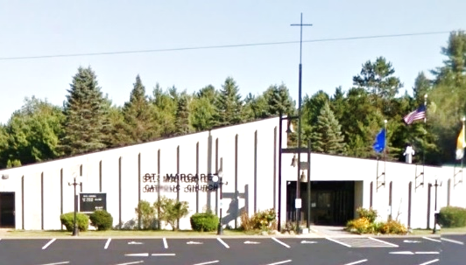
St. Anthony of Padua Sacred Heart of Jesus St. Margaret of Scotland
1432 River St. W778 County Road N N18844 Hwy 141
Niagara, WI 54151 Aurora, WI 54151 P.O. Box 235 Pembine, WI 54156
(715) 251-3879 St. Anthony office hours: Tues 12-3pm & Thurs 9am-12pm (715)324-5849
office.stanthonyniagara@gmail.com Website: www.stanthonyniagara.org stmargaretpembine@gmail.com

Year A:
Holy Family
December 28, 2025

“Do everything in the name of the Lord Jesus”

WEEKEND MASSES

St. Margaret
Saturday at 4:00pm

St. Anthony
Sunday at 9:00 am

Sacred Heart
Sunday at 11:00am
Jan 1st, Mary, Mother of God
Vigil 5:30pm St. Anthony
9am St. Margaret

CONFESSIONS
Wednesday, 5pm St. Anthony
Saturday 8:30-9am St. Anthony
Saturday, 3:30pm St. Margaret
Sunday, 8:30am St. Anthony

Remember, O most gracious Virgin Mary, that never was it known that anyone who fled to thy protection, implored thy help, or sought thy intercession, was left unaided. Inspired by this confidence I fly unto thee, O Virgin of virgins, my Mother. To thee do I come, before thee I stand, sinful and sorrowful. O Mother of the Word Incarnate, despise not my petitions, but in thy mercy hear and answer me. Amen.

WEEKDAY MASSES
Tuesday, 12:30pm St. Anthony
Wednesday, 5:30pm St. Anthony
Thursday, 9:30am Maryhill
Friday, 9am St. Margaret

ADORATION:
Wednesday, 4:30pm St. Anthony
Friday, 8am St. Margaret

Calendar of Events & Mass Intentions:
Saturday, December 27th
8:30-9:30am Confessions at St. Anthony
3:30pm St. Margaret Confession
4pm St. Margaret Mass, Int: Nancy Grandaw
Sunday, December 28th
8:30am St. Anthony Confession
9:00am St. Anthony Mass, Int: Choppers Moreau
11:00am Sacred Heart Mass, Int: For the People
Monday, December 29th
Tuesday, December 30th
12-3pm Dawn’s office hours
12:30pm St. Anthony Mass, Int: Corey Brinkman
Wednesday, December 31^{st –} Vigil to Holy Day
4:30pm Adoration, 5pm Confession
5:30pm St. Anthony Mass Int: For the People
Thurs, January 1st – Holy Day: Mary, Mother of God
9:00am St. Margaret Mass, Int:
Friday, January 2nd – Welcome Fr. Mark
8:30am Confessions
9:00am St. Margaret Mass, Int:
Saturday, January 3rd – Welcome Fr. Mark
8:30-9 am Confessions at St. Anthony
3:30pm St. Margaret Confession
4pm St. Margaret Mass, Int: For the people
Sunday, January 4th – Welcome Fr. Mark
8:30am St. Anthony Confession
9:00am St. Anthony Mass, Int: Nick Burklund
11am Sacred Heart Mass, Int Vonnie VanPembrook

Thank you! To everyone who helped decorate for the Christmas Season.

The Norway Blood Drive will be held on Wednesday, January 14th from 9:00 a.m. to 2:00 p.m. at Norway High School. Anyone able to donate is encouraged to make an appointment by visiting redcrossblood.org or call 1-800-733-2767.

Candle Intentions for St. Anthony
Infant Prague – Special Intention

Candle Intentions for St. Margaret
Child of Prague candles lit for the Walters family ^{(3/28)}
Blessed Virgin Mary Candles lit for the daughters of Bryan; JoAnn, Jaclyn, & Rachel.

STAFF
Pastor: Fr. Joe Dorner
Accountant: Cain Accounting
Secretary& RE Coord: Dawn Johnson, 251-1773
RE Assistant: Donna Henrichs
St A Maintenance: Ken Walenski
St A cleaning person: Veronica Church
St Margaret Secretary: Jenn Cofta
St Margaret Maintenance: Don Cofta
St M Trustees: Andy VandenBush & Ed Nowland
SH Trustees: Jim Carncross & Elise Neuens
St A Trustees: Tony Noska & Judy Parent

GROUP MINISTRIES
- Karen’s Pantry Contact Teresa: 906.239.4662
- Prayer Shawl Ministry –1st Wed at 10am (SUMMERS OFF) Call Cindy Pilon 920.851.7316
SACCW –Pres. Laura Brinkman 906.869.8868. Next meeting is March 2nd 2026 at 5:30pm Weather permitting. Mass intention for Jo Nordell is 3/22/25
- K of C –2nd Monday of month @ 7pm in rectory. Use the southwest entrance of the church
- Councils – next mtg: January 6th 1:30pm St. Margaret and 6pm at St. Anthony (for ST A and Sacred Heart)

Pray for those in need
Mark Van Pembrook, Mary Mitchem, Shirley Geiser, Barry R, Christopher C, Andy Vanden Bush, Butch Rugg, Richard Rugg, Myles Rugg, Jimmy Harper, John Berry, Myah Hood, Roberta Vondall, Jimmy Farrington, Donna Moreau, Mike Michaud, Kim Geib, Kaydence Gilbert, June Anderson, Nick DalSanto, Mary Stewart, Blake Fleury, Mark Endres, John Geib, Peter N., Lucinda Simone, Diane Rock, David Rock Sr., Nathan Glime & family, Elias Zarate, Riley Lestrud, Elijah, Duke family, Neil Anderson, Christopher Schoon, Jenna Erno, Dan Wetzel, Eric Frantz, Keri Rugg, Steve Keeley, Debbie Ziebert, Kelly Jean Rose-Lehto, Trish Gardiner, Robin Rugg, June Uren, Marcie & Jim Crandall, Dick Doucette, Bonnie Nowland, Tom Balthazor, Jana Wood, Kathy Martin, Connor Wallace, Bob Butler, Robert Walters, Jody Wall, Roger Karban, Dan Hughes, Eric Kellings, Barb Schultz
Nursing home: Terry & Cheri Sweig; Kathy & Gerald Kallenbach, Gail Prudhomme, Donna Weber, Helen Kuchinski
Please keep our soldiers in your prayers: Sarah Mills, David Phillips, Emily Phillips, Ben Garvaglia
Please call Rose for intentions 715-251-3249

Weekly Bible Reading for Mass:
Sun the 22nd: Psalter IV, Advent Week 4.
Mic 5:1-4; Ps 80:1-19; Heb 10:5-10; Lk 1:39-45
Mon the 23rd: (John of Kanty, priest.)
Mal 3:1-4:6; Ps 25:4-14; Lk 1:57-66
Tue the 24th: 2 Sam 7:1-16; Lk 1:67-79
Vig: Is62:1-5; Ps89:4-29; Act13:16-25; Mt1:1-25
Wed the 25th: Solemnity of Christmas.
Mdnt: Is9:1-6; Ps96:1-13; Tit 2:11-14; Lk 2:1-14
AM: Is62:11-12; Ps97:1-12; Tit 3:4-7; Lk2:15-20
Day: Is 52:7-10; Ps 98:1-6; Heb 1:1-6; Jn 1:1-18
Thu the 26th: Feast of Stephen, first martyr.
Acts 6:8-10, 7:54-59; Ps 31:3-17; Mt 10:17-22
Fri the 27th: John, apostle and evangelist.
1 John 1:1-4; Ps 97:1-12; Jn 20:1-8
Sat the 28th: Feast of Holy Innocents, martyrs.
1 John 1:5-2:2; Ps 124:1-8; Mt 2:13-18

Sacrificial Giving
Fiscal Year to Date (as of 12/14/25)
Not including income for special projects
 | Budgeted  Income | Actual  Income | W/O grant | With grant
St. A | $62,592.00 | $63,239.74 | 1% | 25%
SH | $16,512.00 | $13,533.83 | -18% | 7%
St. M | $32,282.77 | $33,708.70 | 4% | 33%

BULLETIN AD: If anyone would like an ad or remembrance in the bulletin, please contact Dawn or Jenn. The fee is $200 for a dbl block, $100 for a sngl block, and $50 for a ½ block

That the Creator is in His creature and God is in the flesh brings dignity to man without dishonor to Him who made him. Why then, man, are you so worthless in your own eyes and yet so precious to God?
~ St Peter Chrysologus

2025 St. Margaret Christmas Flower Offering:
- John & Connie Geib
- Suzanne Fabisiak
- Richard Johnson
- Gerard Kwasny
- Bob Kordus
- Jim & Marcie Crandall
  - In Memory of Tony & Annabel Charapata
  - In Memory of Bruce & Alice Crandall
- Ed & Bonnie Nowland:
  - In Memory of Harriet Beffa
  - In Memory of Betty & Francise Nowland
  - In Memory of Bob Parins Sr. & Bob Parins Jr.
  - In Honor of Michelle Brickner
  - In Honor of Tracy Zingler
  - In Honor of Tammy Pelizzario
- Jodi Kinney:
  - In Memory of John & Cecil Heroux
  - In Memory of Bill & Doris Kinney
- Pat Willis:
  - In Memory of Phyllis Willis
- Joan Erickson
  - In Memory of Chet-Frieda & James Londo
- Pam Vross
- David & Katherine Lovato
- Andy & Kathy Vanden Bush
  - In Memory of Rose & Henry Ryczkowski
  - In Memory of Josephine & Clarence Vanden Bush
- Jeanne Swanson
  - In Memory of Bonnie Giessel

KNIGHTS OF COLUMBUS will host a 9-pin bowling tournament on January 17th at Uptown Lanes. There will be 3 flights starting at 12 pm, 3pm and 6pm. For more information, please contact Bob Burton. In our annual Christmas giving meeting the Knights made monetary donations to Karen's Pantry, Pastor Fred's, St. Anthony's, St. Margaret's, Sacred Heart, St. Mary's, Maryhill Manor, The Caring House, and St. Vincent DePaul. The Knight of the month is Andy Herman and the family of the month is Fran and Andy Herman for all the work they do for the Knights' Christmas Party.

In Loving  Memory of:  Pat & Kathy Recl a | Deceased Members  of the Brinkman Family   | In Loving Memory of:  Lyman & Emmeline Johnson   | Evergreen Assisted Living  Dignified Retirement Living  Complete Private Apartments - 3 Meals Daily - Transportation - Medicine Management - Emergency Call System – Memory Care available  774-8943 * 1820 Mary’s Way, Kingsford  Stop in for a personal tour!
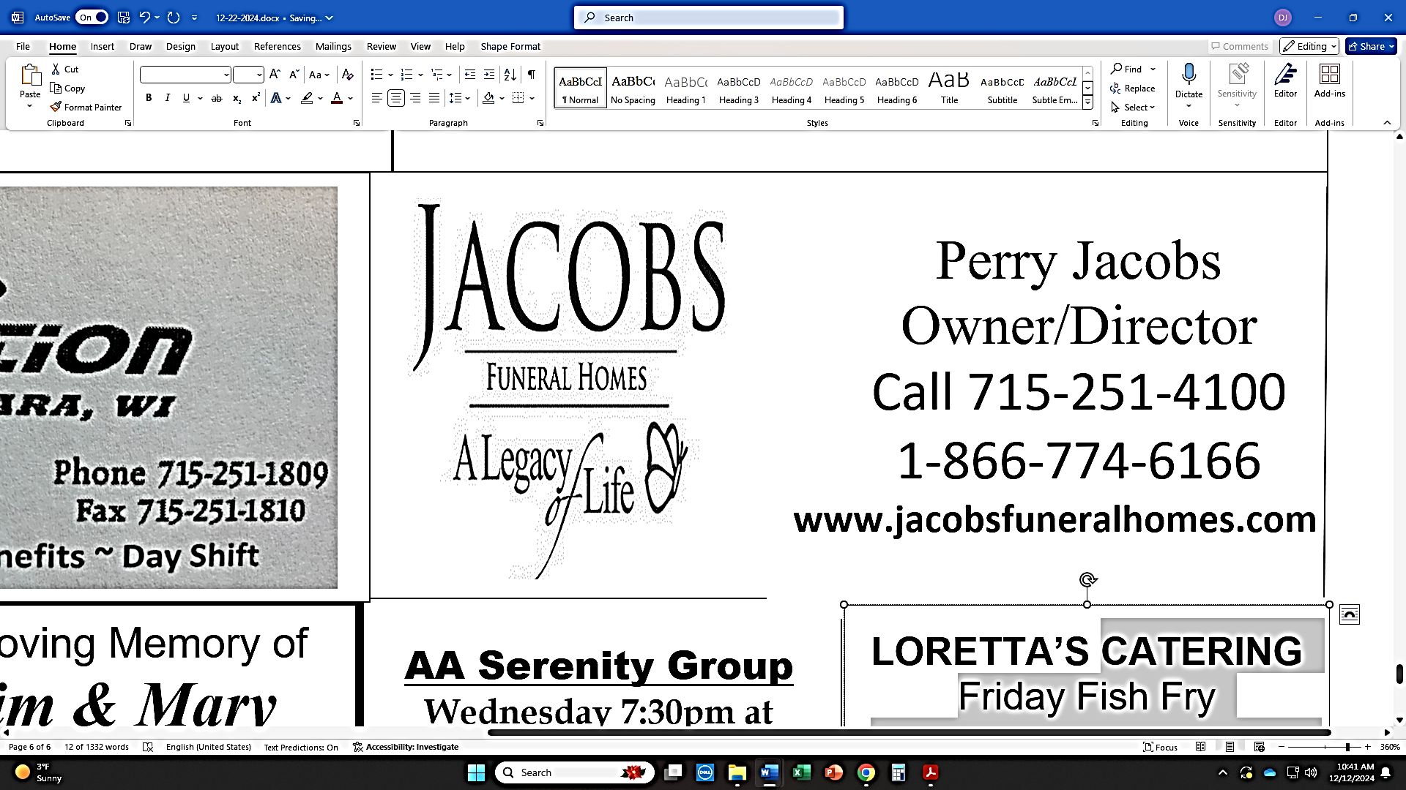  Funeral Homes Crematory |  | 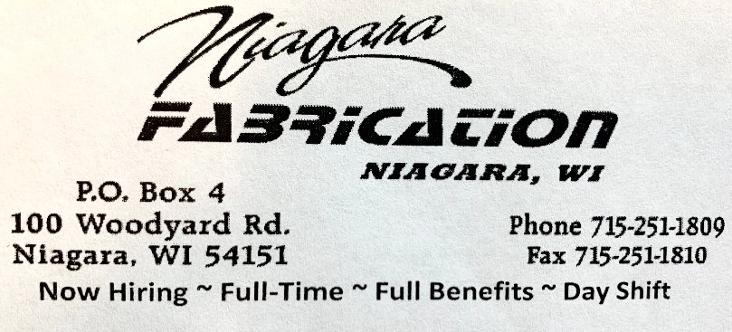
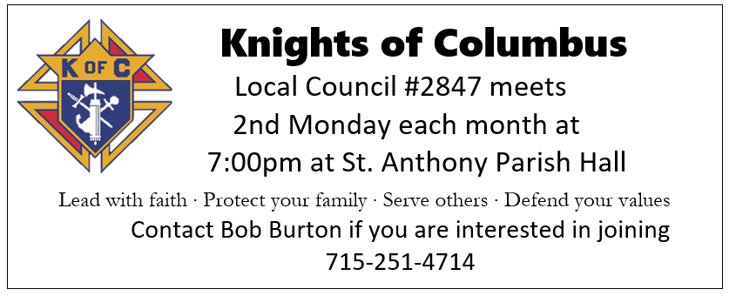 |  | In Memory of the Deceased Members of  Kadulski Family | In Loving Memory of Phyllis Willis  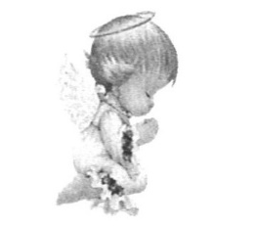
LORETTA’S CATERING
Friday Fish Fry
700 IRON ST. NORWAY, MI 49870
(906) 563-9728
Knights of Columbus Fundraiser  At Uptown Lanes – Niagara, WI    9-pin Bowling Tournament  4-person  Saturday, January 17th, 2026  12pm, 3pm, and 6pm  Sign up at Uptown Lanes  1202 Roosevelt Rd. Niagara, WI  715-251-1700  $30 per bowler per event  (covers bowling & shoes)  *Cash Prizes *  All proceeds go to the Knights of Columbus #2847  AA Serenity Group Wednesday 7:30pm at St. Margaret Parish Call Don 715-929-0011 |  | 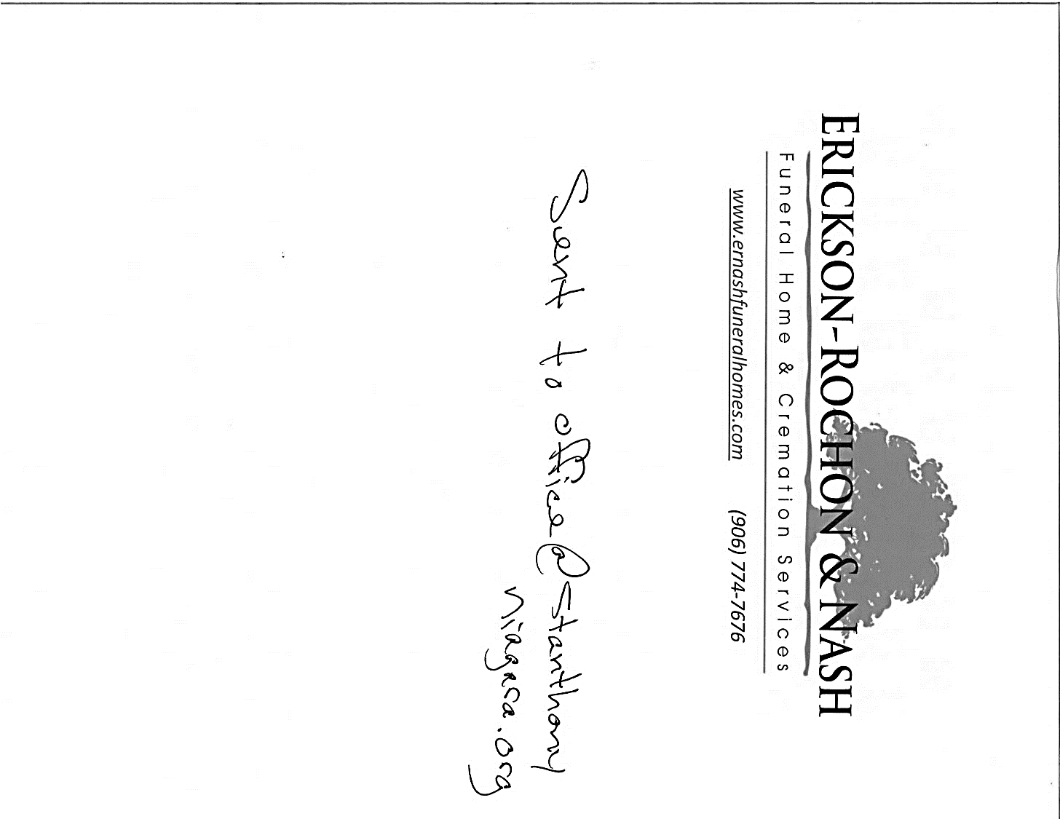
 |  | In Loving Memory of  In loving memory of  George Bousley  Jim & Mary  Parent | 

